

University of Victoria  
Faculty of Engineering

2023 Summer Term  
MECH 400: Design Project

Professor: Colin Bradley   
Teaching Assistant: Shima Akar

Capstone Design Project

Mid-Term Report

2023-06-23

Group 4:

Nipuna Fernando V00912028

Jersey Kertawidjaja V00928025

Duncan Wallace V00877123

Brandon Nolan V00897382

# Table of Contents

Table of Contents 1

Table of Tables 3

Table of Figures 4

Glossary 5

Background 6

1 Introduction 1

2 Requirements and Specifications 3

2.1 Requirements 3

2.2 Specifications 3

2.3 Load Cases 4

3 Deliverables 6

4 Project Management 6

4.1 Timesheet 6

4.2 Gantt Chart 6

5 Design Concepts 7

5.1 Concept 1 7

5.1.1 Overview 7

5.1.2 Insertion and Extraction 8

5.1.3 Construction 9

5.1.4 Advantages 9

5.1.5 Disadvantages 9

5.2 Concept 2 9

5.2.1 Overview 9

5.2.2 Insertion and Extraction 10

5.2.3 Construction 11

5.2.4 Advantages 11

5.2.5 Disadvantages 11

5.3 Concept 3 11

5.3.1 Overview 11

5.3.2 Insertion and Extraction 12

5.3.3 Construction 13

5.3.4 Advantages 13

5.3.5 Disadvantages 13

5.4 Concept 4 13

5.4.1 Overview 13

5.4.2 Insertion and Extraction 14

5.4.3 Construction 15

5.4.4 Advantages 15

5.4.5 Disadvantages 15

5.5 Concept 5 15

5.5.1 Overview 15

5.5.2 Insertion and Extraction 16

5.5.3 Construction 17

5.5.4 Advantages 17

5.5.5 Disadvantages 17

6 Concept Selection 18

6.1 Decision Matrix 18

6.2 Scoring 19

7 Next Steps 20

Appendix A Supporting Documents I

Appendix B Project Management II

Appendix C Decision Matrix III

# Table of Tables

Table 1: Design Requirements for Lifting Mechanism 3

Table 2: Design Requirements for Bracket Chassis 3

Table 3: Design Specifications 4

Table 4: Example Decision Matrix 18

Table 5: Decision matrix with weighted scores for each concept 19

Table 6: Decision Matrix, Criteria Notes for Each Concept III

# Table of Figures

Figure 1: Pictures of Conventional Aerators. 6

Figure 2: Schematic of Proposed GSUI Injector System, note the injector array submerged at the left side of the lagoon. 1

Figure 3: Preliminary SolidWorks model of the injector manifold connected to the vertical feeder pipe. 2

Figure 4: Co-ordinate triad illustrating the relevant axes of orientation. 2

Figure 5: Distinct Load Cases to be considered 5

Figure 6: Concept 1, Isometric sketch of injector array, shortened 7

Figure 7: Concept 1, Injector manifold (as in Figure 6), skeleton diagram showing support points 7

Figure 8: Concept 1, $YZ$-View, Support chassis, Clamping System 8

Figure 9: Concept 1, Isometric Sketch, Two Connected Support Chassis Elements 8

Figure 10: Concept 1, $YZ$-View, Support Chassis, Extraction 8

Figure 11: Concept 2, sketch showing clamping and support features 10

Figure 12: Concept 2, sketch showing extraction features 10

Figure 13: Concept 2, Pier side anti-tip mechanism 10

Figure 14: Concept 3, Isometric view of the hoisting mechanism 12

Figure 15: Concept 3, $XY$ and $YZ$ Views, H Slot Rail and Clamps, Extraction. 12

Figure 16: Concept 4, Assembly 14

Figure 17: Concept 4, Detail View 14

Figure 18: Concept 4, Extraction Mechanism 14

Figure 19: Concept 5, Isometric Sketch, nozzle reducer section (flanges shown) supported by profile cut-outs 16

Figure 20: Concept 5, plan view of injector manifold, showing flanges and supported sections 16

Figure 21: Concept 5, plan view, showing end-mounted ballast tank 17

Figure 22: Schematic for Piping Assembly of Injector Array I

Figure 23: Part of a group member's timesheet, showing the dates and timespan of certain tasks. II

Figure 24: Group Gantt Chart as of 2023-06-23 II

# Glossary

|  |  |  |
| --- | --- | --- |
| Term |  | Definition |
| **Biochemical Oxygen Demand** | BOD | *Oxygen required for the microbial metabolism of organic matter (suspended) in water* |
| **Bill of Materials** | BOM | *An index of items required for an assembly or process* |
| **Computer Aided Design** | CAD | *Use of computers to assist in the creation or analysis of a design* |
| **Chemical Oxygen Demand** | COD | *Oxygen required for reaction in solution* |
| **Engineered Pipe Group** | EPG | *A division of EMCO Corporation, providing piping for wastewater systems* |
| **Finite Element Analysis** | FEA | *Numerical analysis and solution of problems using discrete elements* |
| **Global Solutions Universe Inc.** | GSUI | *An engineering-consulting corporation based in Victoria, British Columbia* |
| **Mazzei Injector Company LLC.** | MICL | *An engineering company focusing on hydrodynamic mixing technologies* |

# Background

Wastewater treatment plays a vital role in maintaining environmental sustainability through the treatment and purification of wastewater before it is discharged into natural water bodies. One of the key processes in wastewater treatment plants comprises of aerators injecting oxygen into wastewater lagoons, this is called the aeration process. The aeration process is performed to meet the oxygen demands of microorganisms (BOD) and chemicals (COD) present in the wastewater, enabling them to decompose the organic matter effectively. In addition to oxygen injection, proper mixing with these lagoons is crucial to prevent the accumulation of hydrogen sulfide in stagnant areas, as it can disrupt the treatment process.

In Canada, much like other countries, surface aerators are commonly used in wastewater treatment plants to achieve aeration and mixing. These aerators employ a method that splashes wastewater at the liquid/gas interface, creating a fine mist and allowing oxygen to interact with the liquid particles. However, this approach presents several issues that are potentially problematic. Firstly, the fine mist generated by surface aerators can be susceptible to wind dispersion, leading to potential environmental contamination. Moreover, in colder climates such as Canada, the wastewater can be cooled by the ambient air temperature, which is detrimental to the activity of the microorganisms decomposing the organic matter. Finally, the electromechanical elements of surface aerators are exposed to the splash zone of the wastewater, causing their components to degrade and fail regularly, increasing maintenance demands.

To overcome the limitations associated with surface aerators, Global Solution Universe Inc. (GSUI) proposes to their client a supplemental oxygen injection method using a venturi nozzle. This innovative approach involves pumping water out of the lagoon, injecting it with oxygen through a venturi nozzle, and reintroducing the aerated water back into the bottom of the lagoon. By injecting aerated water into the depth of the lagoon, the venturi nozzle facilitates efficient oxygen transfer and proper mixing, thereby enhancing the treatment process.

Figure 1:   
Pictures of Conventional Aerators.

# Introduction

Global Solution Universe Inc. (GSUI) is recommending their client (which will be referred to as the “treatment plant” to maintain confidentiality) to implement a supplemental aeration system into their existing aeration basin/lagoon, in addition to their already existing surface aerators. The injector nozzle proposed will inject aerated oxygen into the bottom of the lagoon. GSUI would be sourcing a venturi nozzle and injector nozzles from Mazzei Injector Company LLC. (MICL), a company that design and build the injectors. Whilst the piping and manifold specifications would be sourced from Engineered Pipe Group (EPG).

Figure 2:   
Schematic of Proposed GSUI Injector System, note the injector array submerged at the left side of the lagoon.

GSUI requires a solution to the problem pertaining to the fact that the injectors must be lowered into the aeration lagoon whilst the plant is operational, meaning the lagoon would still be filled with wastewater and have the other surface aerators operational. This challenge is presented by the treatment plant’s desire to not halt their operation. GSUI would also like to propose a way for the client to inspect the injectors in a timeframe of at least five years.

|  |  |
| --- | --- |
|  |  |
| Figure 3:  Preliminary SolidWorks model of the injector manifold connected to the vertical feeder pipe. | Figure 4:  Co-ordinate triad illustrating the relevant axes of orientation. |

The capstone team shall propose a solution to the method of supporting, installing, and inspecting the injector nozzle that could be implemented in the aeration lagoon’s operating conditions. GSUI agrees with the team that a detail design of the support chassis of the manifold array may be prioritized as the topic of the capstone project. But the installation and extraction method of the manifolds would still need to be considered, as it will affect the support chassis in many loading conditions.

# Requirements and Specifications

After communicating with GSUI, the team generated a set of requirements and specifications for the final design with accordance to their problem statement. The team decided to split the requirement for the lifting mechanism and the support chassis separately, but their design would be interconnected. Again, the main detail design of the capstone project shall entail the structural analysis of the support chassis, with considerations and specifications for the lifting mechanism.

## Requirements

After multiple meetings with the GSUI, the requirements of the project were laid out in general form: the project must produce a system capable of withstanding the conditions faced both ambiently and while immersed within the lagoon. The system must be capable of extraction on a semi-regular basis for maintenance. Most importantly, the system must achieve this while supporting the injector array during operation, idle time, and extraction.

|  |  |  |  |
| --- | --- | --- | --- |
| Requirement | | Priority (1 to 3) | Description |
| ID | **Name** |
| 1 | **Lifting Capability** | 3 | The lifting mechanism must be able to lower and lift the injector array whilst the wastewater lagoon is operational (filled). |
| 2 | **Structural Integrity** | 3 | The mechanism of the lifting mechanism must allow for a structurally sound retrieval of the manifold. |

Table 1:   
Design Requirements for Lifting Mechanism

|  |  |  |  |
| --- | --- | --- | --- |
| Requirement | | Priority (1 to 3) | Description |
| ID | **Name** |
| 1 | **Structural Support** | 3 | The bracket supports for the nozzle manifolds must be able to withstand the loading condition presented while the injector is operational. |
| 2 | **Operating Condition** | 3 | The bracket chassis must withstand the operating condition of the wastewater lagoon. |
| 3 | **Material Compatibility** | 3 | The design of the bracket chassis must take into consideration that it would attach to the pipe and/or pipe fittings with specified materials. |
| 4 | **Longevity** | 2 | The longevity of the chassis bracket must be so that it does not take shorter time for it to require maintenance, compared to other surface aerators. |
| 5 | **Maintainability** | 2 | The design of the chassis bracket must be so that the maintenance for the injector nozzle is relatively easier to the other aerators. |

Table 2:   
Design Requirements for Bracket Chassis

## Specifications

After establishing requirements the specifications were subsequently generated, this was achieved through leveraging client documentation, market research and calculations to source concrete values.

|  |  |  |  |
| --- | --- | --- | --- |
| Requirement | | Priority (1 to 3) | Description |
| ID | **Name** |
| 1 | **Lifting Capability** | 3 | Must be able to carry:   * Manifold mass of $141 kg$* Water mass of $861 kg$* The mass of the bracket chassis |
| 2 | **Bracket Structural Support** | 3 | Must be able to withstand:   * Submerged manifold mass. * Thrust generated by the nozzle of $453 lbf$ |
| 3 | **Local Condition** | 3 | The design solution must be able to operate in:   * Local ambient temperature $30 C$* Water temperature ranging from $40 C$ to $50 C$* Suspension density of $5000 ppm$* Acidity of $4 pH$ to $6 pH$ |
| 4/5 | **Longevity and Maintenance** | 2 | * The maintenance period should not span shorter than $5 years$, that of a typical surface aerator. * Able to be feasibly extracted for maintenance through reasonable means. |

Table 3:  
 Design Specifications

## Load Cases

For the structural analysis, the team decided to break up the problem into five separate loading conditions (see Figure 5). Two being the requirements of the lowering (installation) or retrieving (inspection) of the injector manifolds, both when the lagoon is filled with wastewater in operating condition and when it is emptied. Although it is very rare for the concrete lagoon to be emptied, it is possible, typically occurring when lagoon structural repairs are needed. The next two would be the static loading cases, when the nozzle arrays are in place but not operational, again both when the lagoon is operation and when it is drained of its water. The final loading condition would be the operation case, the nozzle array is submerged and fully operating and injecting oxidized water into the lagoon. These loading condition can be seen in detail with imagery in Figure 5. In each case of the loading conditions, except for the operational condition, the team assumes the that the nozzles are clogged and the manifold retaining water, this would allow the team to analyze the structural integrity of the solution conservatively.

Figure 5:   
Distinct Load Cases to be considered

# Deliverables

The project deliverables will include:

* Numerical and computational analysis results of the support chassis.
* Detailed designs of the mounting solution, incorporating specifications for materials and dimensions.
* A bill of materials (BOM) listing all the required components for constructing and installing the mounting solution and venturi nozzle system.
* An animated visual representation illustrating the functionality and working principle of the venturi nozzle system, showcasing its benefits over traditional surface aerators.
* Potentially, a small-scale prototype demonstrating the feasibility of the designed system.

# Project Management

Project management is key to keeping an engineering project organized and efficient. When working as a team it is important to have good project management to keep everyone integrated and working efficiently.

## Timesheet

Since $2023-05-23$, Group 4 has committed to using a centralised timesheet to record times spent during group or project related activities. This has the benefit of providing a log of billable hours and allows the group to review member-by-member activities to verify the group workload is being divided evenly. In the timesheet the date, start time and end time of any work is recorded, in addition to a name and description indicative of the work, from this both the total number of worked hours and daily average may be found for each member of the group. Further information about the timesheet can be found in Appendix B.

## Gantt Chart

In order to keep track of the project timeline and manage prioritisation of tasks, a Gantt chart has been employed to provide a graphical representation of task and deliverable precedence. This allows the group to maintain a sense of the project’s status and visualise obstacles yet to be overcome in the journey to completion. Further information about the Gantt chart can be found in Appendix B.

# Design Concepts

In this section the design concepts are presented and discussed.

## Concept 1

Concept 1 features support provided to the injector system via a chassis system. The injector array is secured to the system via brackets which clamp around the pipe manifold, where each bracket is supported via struts attached to a skid.

### Overview

Figure 6 shows an isometric sketch of the injector array (the span shortened from 8 nozzles to 4), with the manifold positioned in front of the lagoon wall and above the lagoon floor, the stitch lines between sections of the manifold are a simplified representation of where the flanged hardware sections (i.e., pipes, junctions, reducers) connect. As seen in Figure 7, the chassis system would clamp onto the manifold at sections of pipe in between injector nozzles and junction fittings where the absence of features protruding from the pipe radius would provide for an even clamping surface.

|  |  |
| --- | --- |
|  |  |
| Figure 6: Concept 1, Isometric sketch of injector array, shortened | Figure 7: Concept 1, Injector manifold (as in Figure 6), skeleton diagram showing support points |

An impression of the system clamping onto the manifold is provided in Figure 8; the manifold pipe is secured firmly by the clamp, the lower half of which is connected via supporting struts to the skid contacting the bottom of the lagoon. Through the supporting struts and skid, the manifold is provided a reaction to force/moment loads created during injector installation, operation, and extraction. The upper portion of the clamp sees exclusively to the task of affixing the pipe, while the lower section of the assembly is concerned with structural support for the manifold.

To assist with alignment and rigidity between supporting sections, as well as to provide structural support along the span of the manifold, a set of braces connects the supporting sections (visible in Figure 9). The braces avoid adversely loading the manifold (in bending) during extraction due to the added weight of the supports and provides a backbone for the manifold.

|  |  |
| --- | --- |
|  |  |
| Figure 8: Concept 1, $YZ$-View, Support chassis, Clamping System | Figure 9: Concept 1, Isometric Sketch, Two Connected Support Chassis Elements |

A butt-plate (characterized by the $90 °$ bend in the aft section of the skid) is intended to provide a supporting point-of-contact with the lagoon wall during operation and protect the manifold itself from impacting or abrading against the lagoon wall during extraction.

### Insertion and Extraction

The extraction process is shown in Figure 10, the chassis system is extracted via an overhead winch system such as a davit crane. The system is extracted using hoist points on the lower portion of the support section and requires at least four hoist points located in such a manner as to not interfere with the injector array.

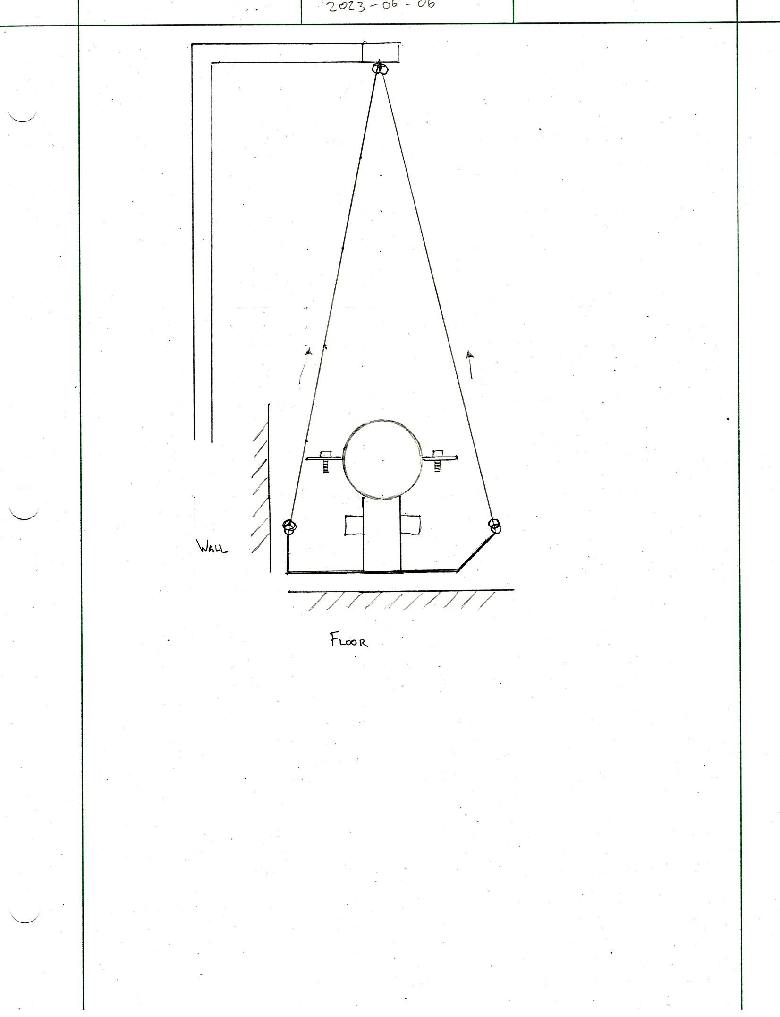

Figure 10:   
Concept 1, $YZ$-View, Support Chassis, Extraction

### Construction

This concept would be fabricated from a combination of-the-shelf materials, such as metal sheet or plate for the skids and metal extrusions for the supporting members, these would be formed using appropriate tools to achieve the desired form in an expedient and low-cost manner (i.e., waterjet cutting, sheet-metal bending). Once the constituent components had been formed, the parts would be welded together to form a monolithic structure capable of receiving the upper clamp.

### Advantages

Advantages of this concept are the relative simplicity of the chassis system, resulting in a low-cost design for which material may be sourced using off-the-shelf stock and formed using basic manufacturing processes. The concept is envisioned such that all load-supporting material is situated below the clamp, which avoids additional stress on the clamp components and results in a low overall center of mass, which lends itself to stability.

### Disadvantages

Disadvantages of this concept are the lack of a positively locating feature, meaning that once situated on the lagoon floor the design is kept in place by the mass of the system and the aligning features of the skid. Another disadvantage to this design is and the requirement for a static 4-point winching system located below the manifold, this leads to a requirement for a larger $Z$-direction distance between winch points during extraction to avoid a system which is both prone to tipping or having the winch constraints (i.e., cables) graze against the manifold at shallow angles.

## Concept 2

The second concept utilizes a motorized pulley hoist on each end of the manifold, connected to the furthest two of the support brackets.

### Overview

Similar to the first concept, the chassis supports the manifolds using brackets located in between the nozzles, as can be seen in Figure 11. Similar to the first concept, these supports would be connected through a single brace that would help mitigate the bending of the manifold when it is being extracted.

|  |  |
| --- | --- |
|  |  |
| Figure 11:  Concept 2, sketch showing clamping and support features | Figure 12:  Concept 2, sketch showing extraction features |

There also exists a clamp that would be mounted to the wall that wraps losely around the vertical pipe section (in extraction), this is done to secure the vertical pipe from tilting forward and falling into the water as it is being lowered or lifted, seen in Figure 12 and Figure 13.

Figure 13:   
Concept 2, Pier side anti-tip mechanism

### Insertion and Extraction

To extract the manifold, after the injector array had been shut down, the clamp would be secured loosely (loose enough to allow for the manifolds to slide between it). The connection between the vertical section and the venturi section would be disconnected. The motorized hoists would then lift the manifold. The clamp supporting the vertical section would be monitored, the vertical pipe section would be guided whenever a flange of a pipe connection goes through the clamp. As a flange connection have gone through (typically a flange connection exists every two meters), the clamp would be tightened. The pipe section above the clamp would then be disconnected, easing the load of the extraction, one section at a time. The steps would be repeated until all the vertical sections have been dismantled and the nozzle array are extracted. The insertion method would be similar, but it would be done in the reverse order.

### Construction

The construction of the support chassis would be fairly similar to the first concept. The only differing aspect being the eyelet welded on the top of the furthest support brackets on either end, as can be seen on Figure 13. The motorized hoists would also need a platform for it to be mounted, of which will likely to have baseplates constructed on the concrete walkway. The same goes for the clamping device of the vertical pipe, it would need to be mounted on the walkway. The details of the construction of these mounting structures have not been further idealized, although designs can be optimized for waterjet cutting and metal bending to keep the manufacturing costs low.

### Advantages

The main advantage to this solution is the added stabilizing point for the vertical pipe. Lifting the support chassis without it would cause a tilting motion of the vertical pipe section. The clamp would also allow the disassembly of the vertical pipe, section by section, as discussed previously.

### Disadvantages

One significant limitation to this concept is that the hoists must overhang against the wall of the lagoon for the cable to lift vertically, which would not allow the manifolds to be lifted over the wall for easier inspection of the horizontal section of the manifold.

Structurally speaking, this concept can be considered to be inferior to the first concept. As Concept 1 connects the wire to the skids of the chassis, the Concept 2 has the wire connected via eyelets on the top half of the bracket, as can be seen in the concept sketch. And because the tension of cable would be attached to the top half of the bracket, there exists a high concentrated stress on the bolts connecting the two halves. Whereas Concept 1 transfers the load directly onto the bottom of the support chassis, as the cables are connected to the skids.

## Concept 3

The third proposed mechanism involves the use of a hoist and a linear slot rail system to lift the piping manifold safely during installation and inspection.

### Overview

The hoisting mechanism comprises several key components. The primary element is the hoist, which has sturdy cables capable of withstanding the pipe manifold's weight. The cables are securely attached equal distance from the vertical section to the horizontal pipe section, ensuring balanced lifting throughout the inspection procedure.

The integration of the H-slot linear rail system as a vertical guide is crucial for maintaining the stability of the pipe manifold during the inspection. By securely clamping the vertical portion of the pipe to the rail, any undesired tilting or misalignment is prevented, ensuring minimum risk of damage to the manifold or surrounding equipment.

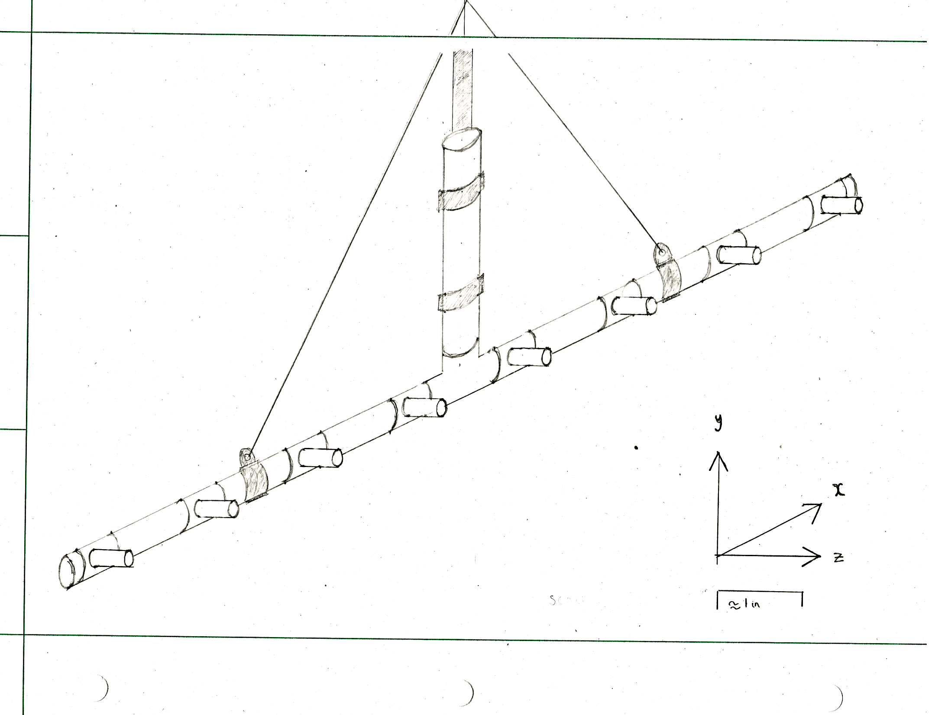

Figure 14:   
Concept 3, Isometric view of the hoisting mechanism

### Insertion and Extraction

During the inspection or installation, the hoist is activated, applying a controlled lifting force to the cables connected to the pipe manifold. As the hoist lifts the manifold, the rollers attached to the H-slot linear rail system ensure smooth and stable movement, eliminating any potential tilting or swinging motion (refer to Figure 15).

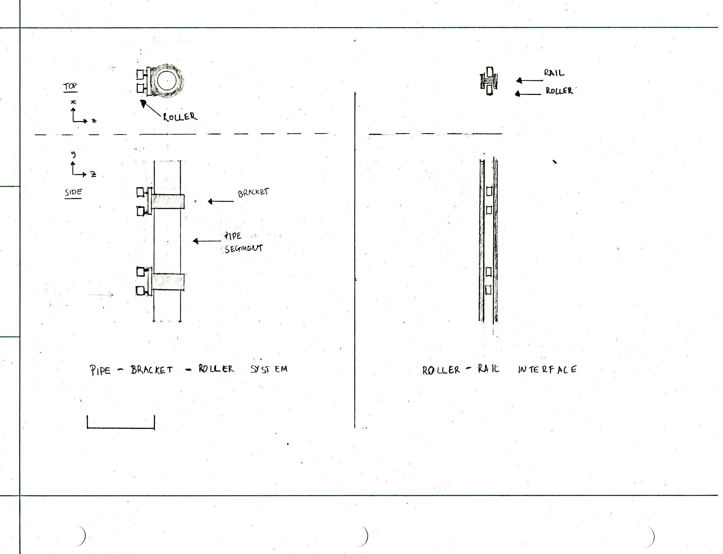

Figure 15:   
Concept 3, $XY$ and $YZ$ Views, H Slot Rail and Clamps, Extraction.

### Construction

The hoist is equipped with strong and reliable cables that are securely attached to both ends of the horizontal pipe section. This balanced attachment ensures even lifting throughout the inspection procedure, preventing any excessive strain on specific areas of the manifold. The H-slot linear rail system components, including the rail, wheels, and clamps, are manufactured using precision machining techniques to ensure accuracy and compatibility. The rail is designed with a H-shaped groove that securely holds the vertical portion of the pipe manifold during lifting and prevents tilting or misalignment. The wheels, attached to the rail, are carefully crafted to provide smooth and stable movement, minimizing any potential swinging or tilting motion. The clamps, used to secure the pipe to the rail, are fabricated with durable materials that can withstand the weight and stress exerted during the inspection process. These components are then assembled, ensuring proper alignment and attachment to create a reliable and robust hoisting mechanism. Stringent quality control measures are implemented throughout the manufacturing process to ensure the final product meets safety and performance standards.

### Advantages

The proposed hoisting mechanism offers several advantages. Firstly, it provides a safer working environment for personnel, minimizing the potential for accidents during the inspection process. Secondly, the use of the H-slot linear rail system significantly reduces the risk of damage to the pipe manifold, as it prevents tilting or misalignment that could occur with conventional lifting methods.

Additionally, the integration of the H-slot linear rail system as a vertical guide ensures stability and precise positioning during the inspection. This prevents tilting or misalignment of the pipe manifold, allowing for accurate examination and reducing the risk of damage to the manifold or surrounding equipment. The hoisting mechanism enables efficient and controlled lifting, ensuring better maneuverability and ease of access for inspection purposes. It also minimizes the risk of damage by preventing collisions with tank walls or other components.

### Disadvantages

Despite its advantages, the proposed hoisting mechanism for pipe manifold inspection also presents some potential disadvantages. Firstly, space limitations within the wastewater tank may pose challenges for the installation of the H-slot linear rail system, potentially restricting the maneuverability of the hoist and the pipe manifold. Careful evaluation of the tank's dimensions is necessary to ensure adequate space for the rail system and associated components. Furthermore, regular maintenance and inspection are also required to ensure the durability of the rail system and its wheels, considering the corrosive nature of the wastewater environment. The increased complexity of the hoisting mechanism compared to traditional inspection methods may result in higher initial costs for equipment, installation, and maintenance.

## Concept 4

Concept 4 is a straightforward design that utilizes a rack-and-pinion mechanism guided by linear rods to lift the manifold in and out of the lagoon safely and effectively.

### Overview

An assembly of the design can be seen in Figure 16.

|  |  |
| --- | --- |
|  |  |
| Figure 16:  Concept 4, Assembly | Figure 17:  Concept 4, Detail View |

In order to keep the manifold stable while both in operation and during extraction, the design has large linear rods imbedded in a concrete block that lays at the bottom of the lagoon. The stability is provided by clamps that that are attached along the downpipe of the manifold; these clamps are fitted to plates with linear bearings affixed to them that use the linear rods as a vertical guide, this can be seen in Figure 12.

### Insertion and Extraction

Figure 18:   
Concept 4, Extraction Mechanism

As can be seen in Figure 13 the insertion and extraction of the manifold is completed using a rack and pinion geartrain. The rack of the geartrain is attached to each clamp along the downpipe and lifts the manifold using the two large pinion gears.

### Construction

The construction of this design is simple, aside from fabricating the metal plates that the downpipe gets clamped to and the concrete block for the linear rods, everything else would be acquired from third party manufacturers. These manufacturers would provide the linear rods, the linear bearings with pillow blocks, the pinion gears for driving the system, the racks along the pipe, and the clamps for the pipe.

### Advantages

When looking at concept 4 one advantage is that with a driving gear that prevents back driving the motor can be removed and reused for multiple manifolds; also, the design allows for versatile positioning of the manifold during extraction. Another advantage of this design is that with the linear rods and bearings the manifold should be stable during extraction.

### Disadvantages

While Concept 4 has some advantages, it also has many disadvantages. One of the main disadvantages of this design is the cost; purchasing 4m long racks as well as the linear rods and bearings already lead to a very high price when comparing it to other solutions. Another disadvantage of this design is that due to the nature of the mechanism when the manifold reaches the top of the lagoon one would have to use an additional device to lift it completely out for disassembly. Another issue with this design is that there is a possibility of matter from the lagoon getting stuck between the gear teeth causing damage over time.

## Concept 5

This concept is characterized by a large flat plate that runs along the floor of the lagoon with supports that are profile cut-outs to provide purchase to various key features along the manifold. The concept is retrieved using a ballast-assisted method.

### Overview

Figure 19 illustrates how a nozzle reducer section would rest in relief-cut recesses in the supporting material, where it might be further secured by bands or lines that run over the top of the pipe fitting. The supporting material itself would be welded to the baseplate and further supported by means of gusset features.

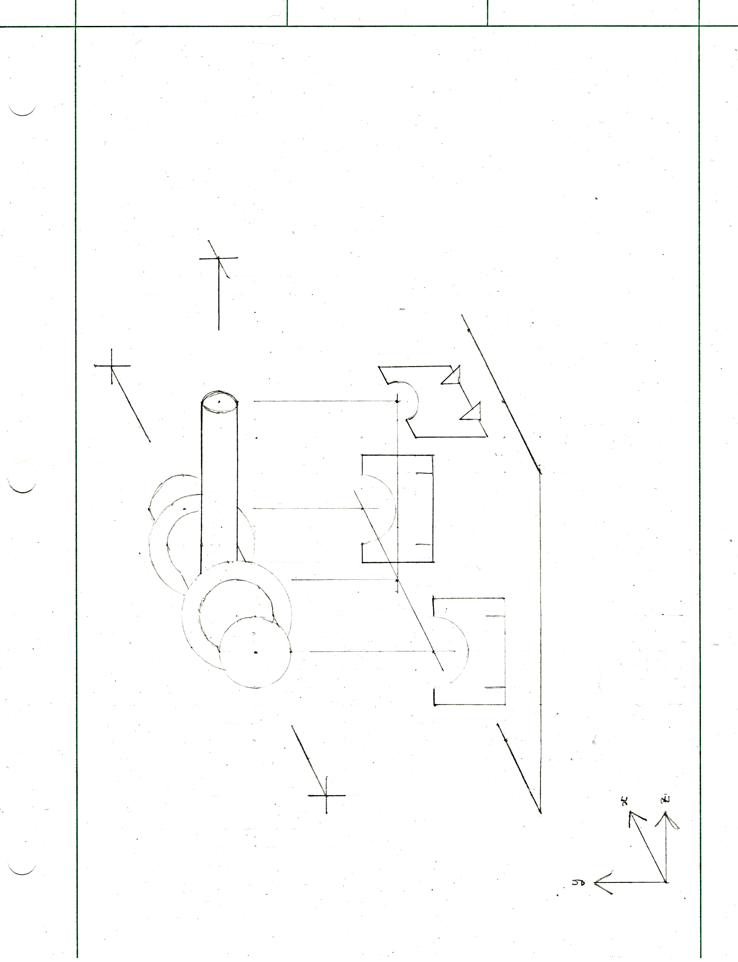

Figure 19:  
Concept 5, Isometric Sketch, nozzle reducer section (flanges shown) supported by profile cut-outs

The support elements pattern across the span of the baseplate, which itself spans the manifold, an impression of the support placement is given below in Figure 20.

|  |  |
| --- | --- |
|  |  |
| Figure 20:  Concept 5, plan view of injector manifold, showing flanges and supported sections | |

### Insertion and Extraction

The concept would feature a pump-ballast system, where ballast tanks mounted at the $X$-axis extremities of the baseplate (seen in Figure 21) would be filled with water to submerge and lower the design, where it would be kept in place at the bottom of the lagoon by its size and mass. To raise the design a pump would be used to fill the ballast tanks with air.

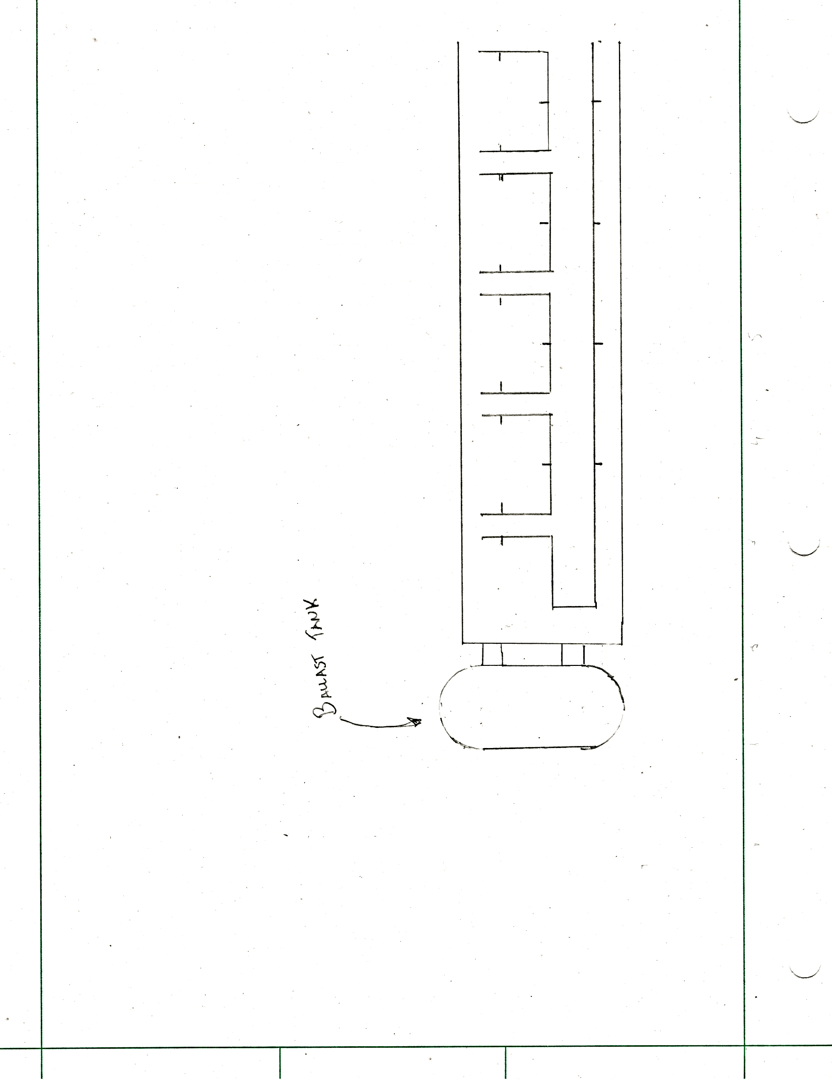

Figure 21:   
Concept 5, plan view, showing end-mounted ballast tank

### Construction

Like prior concepts, this concept would be manufactured predominantly using sheet metal that would be cut and welded together to make a supporting structure. Exceptions to this are the pump and ballast tank systems, which would likely be sourced from third-party manufacturers.

### Advantages

Advantages of this system are its considerable stability owing to its low center of gravity and its relative simplicity in manufacture.

### Disadvantages

Disadvantages of the system are its lack of a controlled ascent and its considerable weight resulting in potential difficulty to extract.

# Concept Selection

In order to decide on the best solution for the given challenge, a weighted decision matrix was made to score each concept based on items from the requirements and specifications section. The concepts with the highest scores will be the designs with the best solutions.

## Decision Matrix

The matrix is composed of requirements that are given a weight from 0 to 1 based on their importance, 0 being irrelevant to the final design and 1 being critical to functionality. The given weights were assigned by the group with input from the client. Each design is then scored on its perceived potential to meet each requirement from 0 to 10, where 0 indicates that the design does not fulfil the criteria at all, and 10 indicates that the design fulfils the criteria elegantly. Each score is then multiplied by the given criteria’s weight producing a value for the concept’s points for that section. After scoring each concept the points are added up and the concept with the most will move forward.

|  |  |  |  |  |  |
| --- | --- | --- | --- | --- | --- |
| Criteria | | Weight | Concept | | |
| **Score (0 to 10)** | **Points** | **Notes** |
| Structural Support | **Static** | 1.00 |  |  |  |
| **Operating** | 1.00 |  |  |  |
| **Extraction** | 1.00 |  |  |  |
| Extraction Method | | 0.80 |  |  |  |
| Immersion Resistance | | 0.70 |  |  |  |
| Ambient Resistance | | 0.40 |  |  |  |
| Maintenance Period | | 0.70 |  |  |  |
| Compatibility | | 1.00 |  |  |  |
| Safety | | 0.70 |  |  |  |
| Integration | | 0.50 |  |  |  |
| Cost | | 0.20 |  |  |  |

Table 4:   
Example Decision Matrix

Table 4 is an example of the decision matrices used to score each concept. The criteria are derived from the requirements and specifications and a description of each one can be found below:

* Structural Support: the ability for concept to withstand the loading cases:
* Static: design is in the lagoon, resting at the bottom
* Operating: design is immersed in the lagoon, resting at the bottom, operating at full capacity
* Extraction: Design is in the lagoon, being raised up
* Extraction Method: The ability for the concept (the structural component in tandem with a removal system) to achieve a complete extraction in a self-contained manner.
* Immersion Resistance: The ability of the concept to withstand the conditions presented by the lagoon.
* Ambient Resistance: The ability of the concept to withstand the conditions presented by the lagoon’s local climes.
* Maintenance Period: The duration between maintenance (compared to surface aerators).
* Compatibility: The compatibility of how the chassis of the support structure fit within the design of the injector manifold.
* Safety: The operating condition for personnels to conduct extraction/maintenance of the injector manifold. The accordance with the safety parameters within the treatment plant.
* Integration: The extent of modifications or alterations required in the lagoon area to harmoniously incorporate the envisioned design concept.
* Cost: The costs incorporate the cost of materials, construction and labour that is required to implement the solution.

## Scoring

The team went through a lengthy discussion over the score of each concept on each of the criteria. The simplified notes of the discussion can be found in Appendix C.

|  |  |  |  |  |  |  |  |
| --- | --- | --- | --- | --- | --- | --- | --- |
| Criteria | | Weight | Points | | | | |
| **Concept 1** | **Concept 2** | **Concept 3** | **Concept 4** | **Concept 5** |
| Structural Support | **Static** | 1.00 | 8.00 | 8.00 | 4.00 | 6.00 | 8.00 |
| **Operating** | 1.00 | 7.00 | 7.00 | 3.00 | 4.00 | 6.50 |
| **Extraction** | 1.00 | 8.00 | 6.00 | 3.00 | 3.00 | 6.00 |
| Extraction Method | | 0.80 | 4.80 | 6.40 | 4.80 | 4.00 | 4.80 |
| Immersion Resistance | | 0.70 | 5.95 | 5.95 | 2.10 | 2.80 | 4.20 |
| Ambient Resistance | | 0.40 | 2.80 | 2.80 | 2.80 | 2.80 | 2.80 |
| Maintenance Period | | 0.70 | 5.60 | 4.55 | 3.85 | 3.50 | 4.20 |
| Compatibility | | 1.00 | 1.00 | 1.00 | 1.00 | 1.00 | 1.00 |
| Safety | | 0.70 | 2.80 | 4.90 | 3.85 | 1.40 | 1.40 |
| Integration | | 0.50 | 4.50 | 3.50 | 1.50 | 2.50 | 3.50 |
| Cost | | 0.20 | 1.80 | 1.40 | 0.40 | 0.80 | 1.00 |
| Total | |  | 52.25 | 51.50 | 30.30 | 31.80 | 43.40 |

Table 5:   
Decision matrix with weighted scores for each concept

As can be seen through the decision matrix scores, Concept 1 scored the highest amongst the other concepts. Additionally, the team decided that since Concept 2 presented valuable characteristics, some of its features would be implemented into the final design. For example, the stabilizing point provided by the clamp around the vertical pipe section helps prevent the vertical pipe from tilting or falling over, which is an important aspect to consider for safe and effective operation of the system.

# Next Steps

As discussed, a culmination of the first two concepts shall be implemented as the final design for the support chassis. As part of developing a final design of the support chassis, an accurate CAD model of the relevant piping assembly shall be constructed, as it will act as a key dimensional constraint. An accurate CAD model of relevant features and connection methods present in the manifold would provide a more accurate and conservative analysis of the structural design.

Once this is complete, material, and dimensional properties for the chassis system will be determined using stress analysis and material mechanics techniques, this will create a first plausible geometry which may be further ratified to generate a fully defined system which is ready for validation.

Once a final design has been generated, structural analysis of the design will be conducted. Loading conditions, as presented in Section 2, shall be analyzed through the means of numerical methods and computational methods (i.e., FEA), hence the importance of the accuracy of the CAD model of the manifold as it would affect the loading conditions and how stresses transfer between connections.

Finally, CAD models and drawings (among other deliverables) will be presented to the GSUI, in fulfilment of their needs and the requirements of this project.

1. Supporting Documents

Figure 22:   
Schematic for Piping Assembly of Injector Array

1. Project Management

An example excerpt from one group members timesheet is provided below in Figure 23.

Figure 23:   
Part of a group member's timesheet, showing the dates and timespan of certain tasks.

From this example one can determine the times a member was working on a certain task, as well as the project total sum of hours ($58 h, 54 min$) and the daily average ($1 h, 54 min$).

An excerpt from the group Gantt chart is provided below in Figure 24.

Figure 24:   
Group Gantt Chart as of 2023-06-23

1. Decision Matrix

The decision matrix was scored by committee. A singular criterion was evaluated for all concepts simultaneously before moving on to the next (i.e., the table was scored on a row-by-row basis). During the scoring process the group notes for each criterion and concept were recorded in Table 6, and serve to justify the evaluation.

Table 6:   
Decision Matrix, Criteria Notes for Each Concept

|  |  |  |  |  |  |  |
| --- | --- | --- | --- | --- | --- | --- |
| Criteria | | Concept 1 | Concept 2 | Concept 3 | Concept 4 | Concept 5 |
| Structural Support | **Static** | Provides even support proportional to number of skids | Same as in Concept 1. | $Y$-support requires constant extractor tension. | Assuming worm-gear primary drive non-back-drivable, allows for versatile positioning, main consideration is spur-gear shearing | Provides additional support to the nozzle shaft. |
| **Operating** | Concept has a low center of mass and a butt-plate. | Same as in Concept 1. | Thrust loading places the rail in bending (assuming no fixed end at the lagoon floor). | Thrust loading places the rail in bending. | Concept is less effective at retaining a clamp on the manifold than 1 or 2. |
| **Extraction** | Skid brace avoids loading in bending, hoist points load at strong point of design. | Same skid-brace as in Concept 1, although loaded top clamp paths load through weak points. | Support method puts the manifold in bending, could be remedied with additional guy wires. | Support method puts the manifold in bending. | $Z$-axis bending on baseplate during ballast pump. |
| Extraction Method | | Lack of upper support to downpipe, reliance on wide skid footprint. | Assuming upper support from vertical brace. | Rail potentially prone to jams, requires dedicated winch. | Guide rods provide problematic geometry, present difficulty in manifold removal. | Assuming guided ascent. |
| Immersion Resistance | | Assuming stainless steel construction. | Same as in Concept 1. | Rail may see fouling. | Gear/Bearing may see fouling. | Ballast valves may see fouling. |
| Ambient Resistance | | Stainless Steel | Same as in Concept 1. | Same as in Concept 1. | Same as in Concept 1. | Same as in Concept 1. |
| Maintenance Period | | Clamp system ought to be serviced. | Clamp could be stretched from extraction. | Wear/tear from guide rail components. | Guide-rod/gear wear/tear and fouling. | Service necessary for ballast valves and pump. |
| Safety | | Geometric propensity to tipping during extraction. | Down-pipe constrained, less likely to tip, required human intervention. | Assuming davit -crane extraction, craning over unsupported/unbraced manifold. | Challenges faces during total manifold removal pose risk for on-site accidents. | System features a high-pressure system, capable of refloating but not reshoring the array. |
| Integration | | Lose one point for eventual davit-crane mounting. | Same as in concept 1, additional bracket. | Requires wall fixturing at both ends of the rail in addition to davit-crane. | Requires wall fixturing strong enough to support whole system. |  |
| Cost | | Sheet-metal, welded. | Sheet metal, welded, on-site fixturing. | Requires linear components, on-site fixturing and lagoon downtime. | Requires relatively advanced components. | Requires ballast tank, valve. |